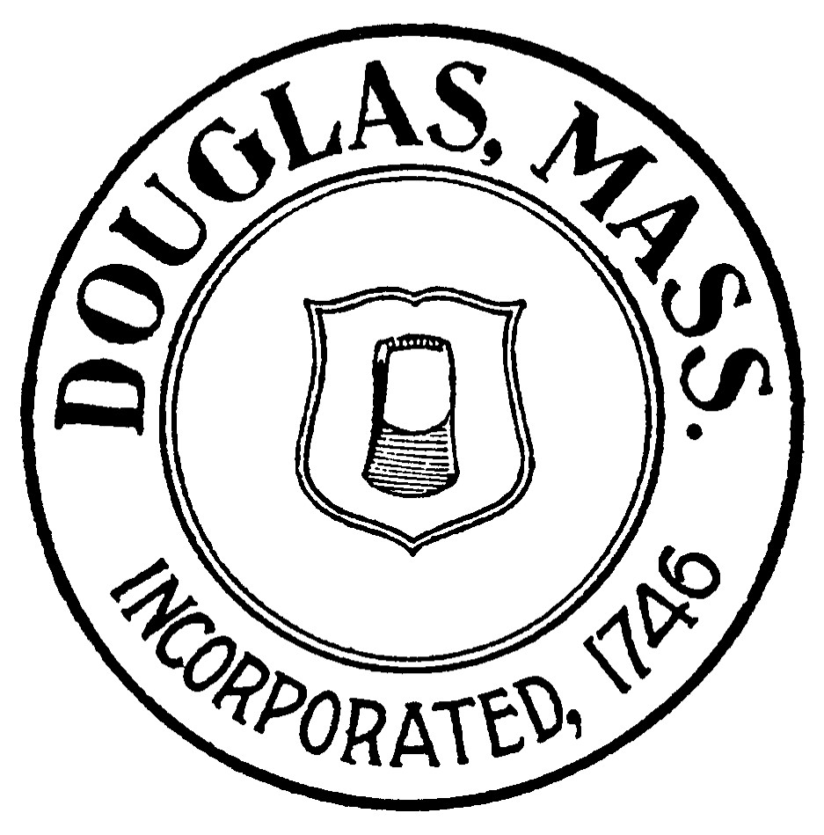
TOWN OF DOUGLAS
BOARD OF HEALTH
29 DEPOT STREET
DOUGLAS, MA 01516
Phone (508)476-4000 x252

APPLICATION FOR FOOD EVENT PERMIT

(NOT INCLUDING FOOD TRUCKS)

Date: _________________________ FEE: One Day: $ 35/day or
Season: $125

EVENT INFORMATION:

Name of EVENT:__________________________________________________________

EVENT Location:__________________________________________________________

Date(s) you plan on Participating at Event: _______________________________________

EVENT Hours of Operation:___________________________________________________

EVENT Contact Person (Name & Phone#):________________________________________

EVENT UTILITIES:
Will Electricity be provided to Food Booths: YES NO
Describe Potable Water Supply:______________________________________________
Describe means for Wastewater Disposal:_______________________________________
Describe means for Garbage Disposal & Collection:_______________________________

FOOD VENDOR INFORMATION:

Business Name: _________________________________________________

Business Address: ________________________________________________________

Telephone Number: _______________________________________________________

Applicants Name __________________________________________________________

Who in your organization holds the ServSafe and Allergen Awareness Certifications?
(ALL CERTIFICATIONS MUST BE ATTACHED TO APPLICATION)

__________________________________________________________________

Where will the food be prepared? ____________________________________________

Page 1
Please attach most recent inspection report and current food establishment license.

Please list the items you are selling and a description of the means of preparation: ________________________
__________________________________________________________________________________________
__________________________________________________________________________________________
__________________________________________________________________________________________

Please describe how items will be kept hot/cold:___________________________________________________
__________________________________________________________________________________________
__________________________________________________________________________________________

Food Booth Structure: Booth Tent Food Cart Other:________________

Hand-washing facilities available at booth? YES NO (If no, please explain method of hand-washing):
____________________________________________________________________________________

Will Gloves be available for use by your employees? ___________# of Employees:__________
Disposable gloves & hand sanitizers can provide an additional barrier to contamination but are NOT a substitute for handwashing.

Do you have immediate access to a dishwasher or 3-compartment sink?___________
If not, please explain method of cleaning utensils and equipment:_________________________________
_______________________________________________________________________________________

Utensils must be cleaned or replaced every 4 hours! Separate utensils must be utilized for handling raw and cooked animal foods during the cooking process!!

Type of Sanitizer you will be using:___________________ (Sanitizer test kit must be available for use at food booth). All food contact surfaces must be sanitized and kept clean at all times.

FOOD PREPARATION:

Menu – Attach or list ALL food items to be served at EVENT:______________________________________
__________________________________________________________________________________________
__________________________________________________________________________________________
__________________________________________________________________________________________

Will all foods be prepared at the event in the temporary food service booth?

_______YES fill out Section B below _________NO Fill out Sections A and B below:

Page 2

SECTION A: At the approved kitchen
(You MUST attach copy of permit and agreement for use of another licensed food establishment along with their MOST RECENT Inspection Report)

List each potentially hazardous food item, and for each item check which preparation procedure will occur.
FOOD | Thaw | Cut/  Assemble | Cook | Cool | Cold  Holding | Reheat | Hot  Holding

SECTION B: At the booth:
FOOD | Thaw | Cut/  Assemble | Cook | Cool | Cold  Holding | Reheat | Hot  Holding

FOOD PROTECTION, TRANSPORTATION & STORAGE

Describe measures to protect food and maintain temperature (HOT and COLD) during transportation from approved kitchen to event booth:_______________________________________________________________
__________________________________________________________________________________________
____________________________________________________________________________________________________________________________________________________________________________________

Describe measures to protect food and maintain temperature (HOT and COLD) while in storage at event booth:
______________________________________________________________________________________________________________________________________________________________________________________________________________________________________________________________________________

Describe measures to protect food and maintain temperature (HOT and COLD) during display at event booth:
______________________________________________________________________________________________________________________________________________________________________________________________________________________________________________________________________________

Food grade thermometers MUST be on-site to verify hot and cold temperatures.

Water and Ice MUST be from an approved source – list source(s): ____________________________________

Page 3

Ice used for cold storage of food products MUST NOT be dispensed for consumption to consumer
Packaged foods may not be stored in direct contact with ice or water if the food is subject to the entry of water because of the nature of its packaging, wrapping, its container or its positioning in the ice or water – Unpackaged food may not be stored in direct contact with un-drained ice.

Explain how food stored in ice will be adequately protected from melting water?________________________
________________________________________________________________________________________________________________________________________________________________________________________________________________________________________________________________________________________________________________________________________________________________________

How will FROZEN foods be thawed, if necessary, prior to service? ___________________________________
____________________________________________________________________________________________________________________________________________________________________________________
__________________________________________________________________________________________

Food source(s) – please list all locations at which food will be purchased for this event:____________________
____________________________________________________________________________________________________________________________________________________________________________________
__________________________________________________________________________________________

No foods made in a RESIDENTIAL KITCHEN shall be allowed at any temporary food event! (Exception: Bake Sale items such as cookies, brownies, or cakes)

I certify by signing this application that I have received and read the Massachusetts Department of Public Health “Are You Ready?” checklist for Temporary Food Establishment Operations, and that I am familiar with 105 CMR 590.000 Minimum Standards for Food Establishments and that the described establishment will be operated and maintained in accordance with the regulations.

_________________________ ___________________________________
Date Signature of Food Vendor Applicant

Page 4

